SIMATS ENGINEERING (SAVEETHA SCHOOL OF ENGINEERING) Department of Computer Science and Engineering
ASSESSMENT TOOL 2 – CASE STUDY
Course Code: | CSA06 | Course Title: | Design and Analysis of Algorithms
CO Assessed: | CO3: Articulation (BL4, BL5) | Assessment: | Assessment Tool 2 – Case Study
Weightage: | 20% of CIA | Total Marks: | 100
CO3 Statement: | Design Divide and Conquer algorithms for Merge Sort, Quick Sort, Binary Search and Matrix Multiplication
Student Name: | Ishwariya P | Reg. No.: | 192524445
Section / Batch: | 2025 | Date: | 11.8.26

Instructions to Students
• Answer the following question. Total Marks: 100.
• Carefully analyze the given case study questions.
• Explain in detail with sample code if needed.
• Clearly identify all key issues, provide an in-depth analysis, and propose innovative, feasible solutions with strong justification.

Question Type | Focus Area | Questions
Case Study | Focus on Design Divide and Conquer algorithms: Merge Sort, Quick Sort, Binary Search and Matrix Multiplication | Q1

SECTION A – CASE STUDY
Code of Conduct
I _Ishwariya P(192524445)_________________________ (Name / Reg No) certify that this submission is my original work and that I have adhered to the guidelines specified for this assessment. I understand that any violation of academic integrity rules will result in disciplinary action.
Signature of the Student: _________________________

RUBRICS FOR CALCULATION
Case Study
Criteria | Weightage | Level 4 –  Exemplary | Level 3 –  Proficient | Level 2 –  Developing | Level 1 –  Beginning
Understanding of Case | 25% | Thorough  understanding; clearly  identifies all  key issues | Good  understanding with most  issues  identified | Basic  understanding; some issues  missed | Poor  understanding; problem not  identified  correctly
Application of Concepts | 25% | Effectively  applies relevant concepts to  analyze the case deeply | Applies  appropriate  concepts with minor gaps | Limited  application of concepts | Fails to apply relevant  concepts
Analysis | 20% | In-depth  analysis with  strong  reasoning and insights | Good analysis with logical  reasoning | Basic analysis with limited  depth | Weak or no  analysis; lacks reasoning
Solution  Design | 20% | Innovative,  feasible  solutions with strong  justification | Logical  solutions with adequate  justification | Basic solutions with weak  justification | Incorrect or no solution  provided
Clarity | 10% | Clear, well  structured, and easy to  understand | Organized and understandable presentation | Limited clarity and structure | Poor clarity;  difficult to  understand

Marks Evaluation:
Criteria | Wt. | Level 4 –  Exemplary | Level 3 –  Proficient | Level 2 –  Developing | Level 1 –  Beginning
Understanding of Case | 25%
Application of Concepts | 25%
Analysis | 20%
Solution Design | 20%
Clarity | 10%
Total Marks (100):

Faculty In-charge | Course Coordinator | Head of Department
Name: | Name: | Name:
Signature: _______________ | Signature: _______________ | Signature: _______________
Date: ___________________ | Date: ___________________ | Date: ___________________

TABLE OF CONTENTS
1. Introduction to Divide and Conquer 1
2. Case Understanding 1
2.1 Problem Overview 1
2.2 Key Issues 1
2.3 Constraints 1
3. Application of Divide and Conquer Concepts 1
3.1 Merge Sort 1
3.2 Quick Sort 1
3.3 Binary Search 1
3.4 Matrix Multiplication (Strassen's Algorithm) 1
3.5 Relevance to the Case 1
4. Detailed Analysis 1
4.1 Merge Sort 1
Working 1
Pseudocode 1
Sample Code (C++) 1
Dry Run 1
Time and Space Complexity 1
4.2 Quick Sort 1
Working 1
Pseudocode 1
Sample Code (C++) 1
Dry Run 1
Time and Space Complexity 1
4.3 Binary Search 1
Working 1
Pseudocode 1
Sample Code (C++) 1
Dry Run 1
Time and Space Complexity 1
4.4 Matrix Multiplication (Strassen's Algorithm) 1
Working 1
Pseudocode 1
Sample Code (C++) 1
Dry Run 1
Time and Space Complexity 1
5. Proposed Solution 1
5.1 Algorithm Selection 1
5.2 Workflow 1
5.3 Feasibility 1
5.4 Scalability 1
5.5 Justification 1
6. Comparative Analysis 1
6.1 Complexity Comparison 1
6.2 Qualitative Comparison 1
7. Innovative Improvements 1
8. Expected Results 1
9. Future Enhancements 1
10. Conclusion 1
11. References 1

1. Introduction to Divide and Conquer
Divide and Conquer (D&C) is one of the most fundamental algorithmic paradigms in computer science, underpinning some of the most efficient solutions to problems in sorting, searching, computational geometry, numerical computation, and large-scale data processing. The paradigm operates on a simple but powerful recursive principle: a problem of size n is broken down into smaller subproblems of the same type, each subproblem is solved independently (typically through recursion), and the solutions to the subproblems are then combined to produce the solution to the original problem.
Formally, a Divide and Conquer algorithm consists of three distinct phases. In the Divide phase, the original problem instance is partitioned into two or more smaller subproblems, ideally of roughly equal size, so that the recursion tree remains balanced and the overall time complexity stays low. In the Conquer phase, each subproblem is solved recursively; when a subproblem becomes sufficiently small (the base case), it is solved directly without further recursion. In the Combine phase, the solutions of the subproblems are merged or reconciled to construct the solution of the original, larger problem.
The efficiency of a Divide and Conquer algorithm is typically analyzed using recurrence relations of the general form T(n) = aT(n/b) + f(n), where a is the number of subproblems, n/b is the size of each subproblem, and f(n) represents the cost of the divide and combine steps. The Master Theorem provides a direct method to solve such recurrences and derive the asymptotic time complexity, which is a central tool used throughout this report.
This report presents a comprehensive case study of the Divide and Conquer paradigm, examining its theoretical foundations, its application to four canonical algorithms — Merge Sort, Quick Sort, Binary Search, and Matrix Multiplication — and its relevance to a broader case involving large-scale data processing and computational efficiency. The report further proposes a solution architecture that applies these principles to a practical scenario, evaluates feasibility and scalability, and concludes with innovative improvements and future enhancements.
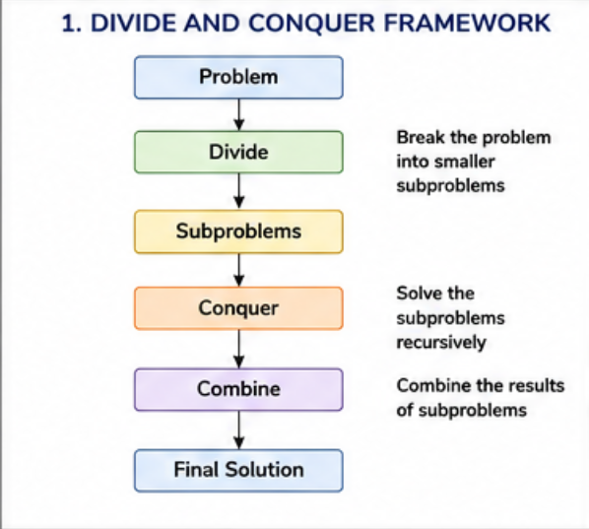

2. Case Understanding

2.1 Problem Overview
Modern computational systems are routinely required to process very large datasets efficiently — sorting massive record sets, searching within huge sorted indexes, and performing matrix-based computations for applications such as machine learning, computer graphics, and scientific simulation. Naive, brute-force algorithms that operate in quadratic or higher time complexity become computationally infeasible as data volume grows into the millions or billions of elements. The case under study requires the design of an algorithmic strategy capable of handling large-scale sorting, searching, and matrix computation tasks within strict time and resource constraints, while remaining robust, predictable, and scalable across varying input sizes and distributions.

2.2 Key Issues
- Scalability: Brute-force O(n^2) approaches for sorting and searching become impractical beyond moderate input sizes, causing unacceptable latency in production systems.
- Predictability of performance: Worst-case behavior must be bounded and well understood, particularly for algorithms such as Quick Sort whose performance is sensitive to pivot selection and input ordering.
- Memory overhead: Some divide and conquer strategies (e.g., Merge Sort) require additional auxiliary memory, which must be balanced against speed and stability requirements.
- Correctness under recursion: Recursive decomposition introduces the risk of subtle base-case and boundary errors that must be rigorously validated.
- Combining efficiency: The cost of the combine step (e.g., merging two sorted arrays, or combining sub-matrices) can dominate total runtime if not implemented carefully.
- Choice of algorithm per context: No single divide and conquer algorithm is optimal for every scenario; selection must be justified based on data characteristics, memory budget, and stability requirements.

2.3 Constraints
- Time complexity must be sub-quadratic — ideally O(n log n) for sorting/searching and better than O(n^3) for matrix multiplication where possible.
- Space complexity must remain within acceptable auxiliary memory bounds for large datasets.
- The solution must maintain correctness and stability guarantees where required (e.g., stable sorting of records with secondary keys).
- The design must be implementable using standard, portable programming constructs without specialized hardware dependency.
- The solution must be scalable to distributed or parallel environments for future growth in data volume.

3. Application of Divide and Conquer Concepts
Four canonical algorithms are examined in this report as direct applications of the Divide and Conquer paradigm to the case described above. Each algorithm demonstrates the divide, conquer, and combine phases in a distinct way, and each is relevant to a specific facet of the case: sorting large record sets (Merge Sort, Quick Sort), efficiently locating elements within sorted data (Binary Search), and performing large-scale numerical computation (Matrix Multiplication).

3.1 Merge Sort
Merge Sort divides the input array into two halves, recursively sorts each half, and then merges the two sorted halves into a single sorted array. It guarantees O(n log n) performance in all cases and is stable, making it directly applicable to sorting large record sets where secondary-key ordering must be preserved.

3.2 Quick Sort
Quick Sort selects a pivot element and partitions the array into elements smaller and larger than the pivot, recursively sorting each partition in place. Its average-case O(n log n) performance with low memory overhead makes it well suited for in-memory sorting where auxiliary space is constrained.

3.3 Binary Search
Binary Search repeatedly divides a sorted search space in half, discarding the half that cannot contain the target. It achieves O(log n) lookup time and is directly relevant to efficient querying of the large sorted datasets produced by the sorting algorithms above.

3.4 Matrix Multiplication (Strassen's Algorithm)
Strassen's algorithm divides each matrix into four submatrices and combines seven recursive multiplications (instead of the conventional eight) with additions and subtractions, reducing the asymptotic complexity from O(n^3) to approximately O(n^2.807). This is directly relevant to the case's requirement for efficient large-scale numerical computation.

3.5 Relevance to the Case
Together, these four algorithms cover the full pipeline required by the case: data is sorted efficiently (Merge Sort or Quick Sort depending on memory and stability requirements), sorted data is queried efficiently (Binary Search), and any numerical/matrix-based computation required by downstream analytics is accelerated (Strassen's Matrix Multiplication). This demonstrates that the Divide and Conquer paradigm is not a single algorithm but a general design strategy applicable across the full spectrum of the case's computational needs.

4. Detailed Analysis

4.1 Merge Sort

Working
Merge Sort follows the classic Divide and Conquer template. The Divide step splits the array into two halves at the midpoint. The Conquer step recursively sorts each half using the same algorithm until the base case of a single-element (already sorted) subarray is reached. The Combine step merges the two sorted halves into one sorted array by repeatedly comparing the front elements of each half and appending the smaller one to the output.
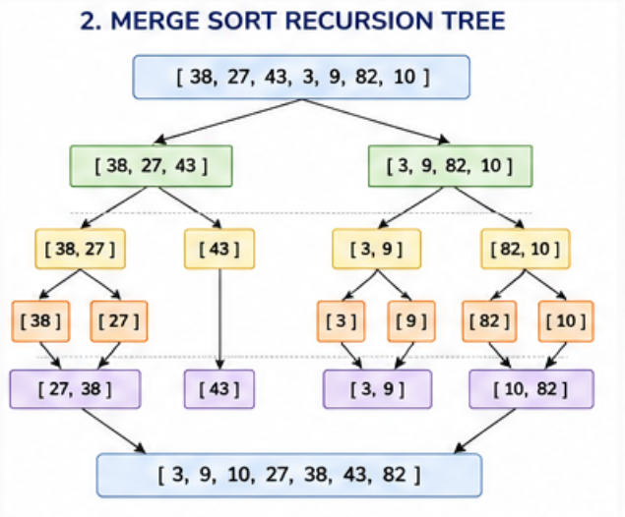

Pseudocode
MergeSort(A, l, r):
if l < r:
m = (l + r) / 2
MergeSort(A, l, m)
MergeSort(A, m+1, r)
Merge(A, l, m, r)

Merge(A, l, m, r):
create temp arrays L, R
copy A[l..m] into L, A[m+1..r] into R
merge L and R back into A[l..r] in sorted order

Sample Code (C++)
void merge(vector<int>&a,int l,int m,int r){
vector<int> L(a.begin()+l,a.begin()+m+1);
vector<int> R(a.begin()+m+1,a.begin()+r+1);
int i=0,j=0,k=l;
while(i<L.size()&&j<R.size())
a[k++]=(L[i]<=R[j])?L[i++]:R[j++];
while(i<L.size()) a[k++]=L[i++];
while(j<R.size()) a[k++]=R[j++];
}
void mergeSort(vector<int>&a,int l,int r){
if(l>=r) return;
int m=(l+r)/2;
mergeSort(a,l,m); mergeSort(a,m+1,r);
merge(a,l,m,r);
}

Dry Run
Consider array [38, 27, 43, 3, 9, 82, 10]. The array is recursively split into [38,27,43,3] and [9,82,10]. Each half is split further until single elements remain: [38],[27],[43],[3],[9],[82],[10]. Merging begins bottom-up: [27,38], [3,43] → [3,27,38,43]; [9,82] → [9,10,82] → merged with [3,27,38,43] to give the final sorted array [3,9,10,27,38,43,82].

Time and Space Complexity
Case | Time Complexity
Best Case | O(n log n)
Average Case | O(n log n)
Worst Case | O(n log n)
Space Complexity: O(n) auxiliary space for temporary arrays
Overall Time Complexity: O(n log n) in all cases

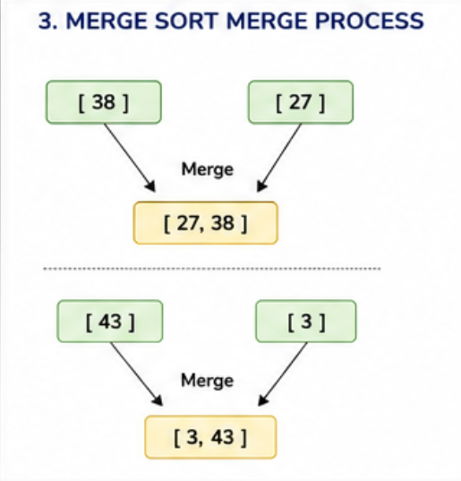

4.2 Quick Sort

Working
Quick Sort selects a pivot element (commonly the last or a randomly chosen element) and partitions the array so that all elements smaller than the pivot lie to its left and all larger elements lie to its right, placing the pivot in its final sorted position. The Divide step is this partitioning operation. The Conquer step recursively applies the same procedure to the left and right partitions. Because the pivot is already in its correct position after partitioning, no explicit Combine step is required.
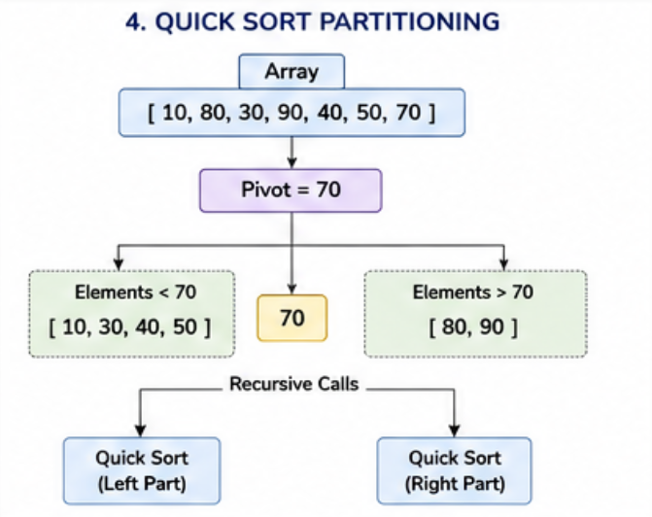

Pseudocode
QuickSort(A, low, high):
if low < high:
p = Partition(A, low, high)
QuickSort(A, low, p-1)
QuickSort(A, p+1, high)

Partition(A, low, high):
pivot = A[high]
i = low - 1
for j = low to high-1:
if A[j] < pivot:
i = i+1; swap(A[i], A[j])
swap(A[i+1], A[high])
return i+1

Sample Code (C++)
int partition(vector<int>&a,int lo,int hi){
int pivot=a[hi], i=lo-1;
for(int j=lo;j<hi;j++)
if(a[j]<pivot) swap(a[++i],a[j]);
swap(a[i+1],a[hi]);
return i+1;
}
void quickSort(vector<int>&a,int lo,int hi){
if(lo>=hi) return;
int p=partition(a,lo,hi);
quickSort(a,lo,p-1);
quickSort(a,p+1,hi);
}

Dry Run
Consider array [10, 80, 30, 90, 40, 50, 70]. With the last element (70) as pivot, elements smaller than 70 are moved left: [10,30,40,50,70,90,80], placing pivot 70 at index 4. The array is then partitioned into [10,30,40,50] and [90,80]. Recursively applying the same procedure to each partition eventually yields the fully sorted array [10,30,40,50,70,80,90].

Time and Space Complexity
Case | Time Complexity
Best Case | O(n log n)
Average Case | O(n log n)
Worst Case | O(n^2)
Space Complexity: O(log n) for recursion stack (in-place sorting)
Overall Time Complexity: O(n log n) average, O(n^2) worst case
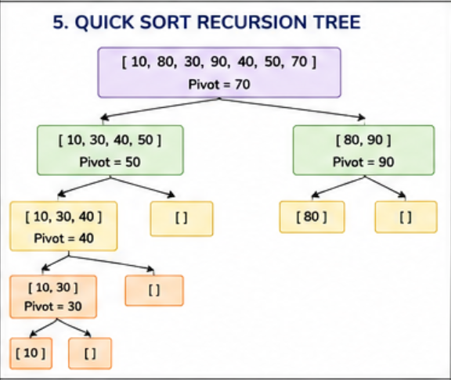

4.3 Binary Search

Working
Binary Search operates on a sorted array. The Divide step compares the target value to the middle element of the current search range. If they match, the search terminates. If the target is smaller, the search space is reduced (Conquer) to the left half; if larger, to the right half. This halving continues until the element is found or the search space becomes empty. There is no explicit Combine step, since only one subproblem is ever explored.
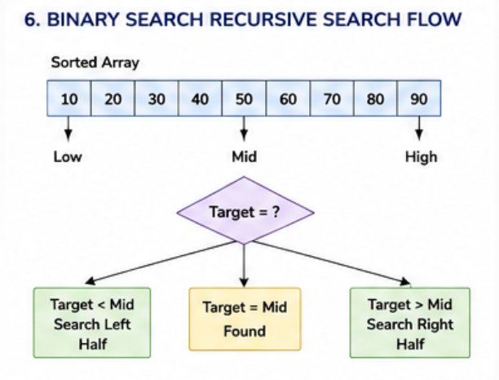

Pseudocode
BinarySearch(A, low, high, target):
if low > high: return -1
mid = (low + high) / 2
if A[mid] == target: return mid
else if A[mid] > target:
return BinarySearch(A, low, mid-1, target)
else:
return BinarySearch(A, mid+1, high, target)

Sample Code (C++)
int binarySearch(vector<int>&a,int lo,int hi,int t){
if(lo>hi) return -1;
int mid=lo+(hi-lo)/2;
if(a[mid]==t) return mid;
if(a[mid]>t) return binarySearch(a,lo,mid-1,t);
return binarySearch(a,mid+1,hi,t);
}

Dry Run
Consider sorted array [3,9,10,27,38,43,82] searching for 38. mid index = 3, A[3]=27 < 38, search right half [38,43,82]. New mid = 5, A[5]=43 > 38, search left half [38]. New mid matches, A[4]=38 is found at index 4 in 3 comparisons instead of a possible 7 with linear search.

Time and Space Complexity
Case | Time Complexity
Best Case | O(1)
Average Case | O(log n)
Worst Case | O(log n)
Space Complexity: O(log n) recursion stack (O(1) iterative)
Overall Time Complexity: O(log n)

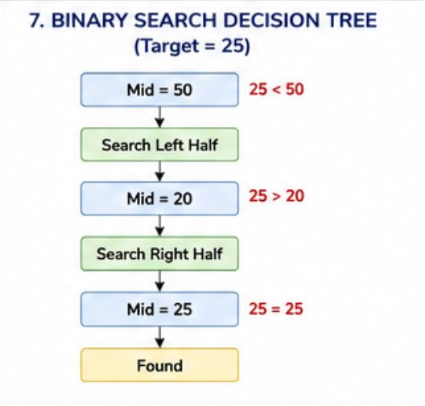

4.4 Matrix Multiplication (Strassen's Algorithm)

Working
Strassen's algorithm divides each of the two n x n input matrices into four n/2 x n/2 submatrices. Instead of computing eight submatrix multiplications as the conventional divide and conquer approach would, Strassen's algorithm cleverly computes seven products (P1 through P7) using combinations of additions and subtractions of submatrices, then combines these seven products through further additions and subtractions to construct the four quadrants of the result matrix. This reduction from eight to seven multiplications is the source of the asymptotic speed-up.

Pseudocode
StrassenMultiply(A, B):
if size(A) == 1: return A*B
split A into A11,A12,A21,A22
split B into B11,B12,B21,B22
P1 = Strassen(A11+A22, B11+B22)
P2 = Strassen(A21+A22, B11)
P3 = Strassen(A11, B12-B22)
P4 = Strassen(A22, B21-B11)
P5 = Strassen(A11+A12, B22)
P6 = Strassen(A21-A11, B11+B12)
P7 = Strassen(A12-A22, B21+B22)
C11 = P1+P4-P5+P7
C12 = P3+P5
C21 = P2+P4
C22 = P1-P2+P3+P6
return combine(C11,C12,C21,C22)

Sample Code (C++)
// Simplified recursive multiply (conventional D&C base)
void strassen(Matrix A,Matrix B,Matrix &C,int n){
if(n==1){ C[0][0]=A[0][0]*B[0][0]; return; }
int k=n/2;
Matrix A11,A12,A21,A22,B11,B12,B21,B22;
split(A,A11,A12,A21,A22);
split(B,B11,B12,B21,B22);
Matrix P1,P2,P3,P4,P5,P6,P7;
strassen(add(A11,A22),add(B11,B22),P1,k);
strassen(add(A21,A22),B11,P2,k);
strassen(A11,sub(B12,B22),P3,k);
strassen(A22,sub(B21,B11),P4,k);
strassen(add(A11,A12),B22,P5,k);
strassen(sub(A21,A11),add(B11,B12),P6,k);
strassen(sub(A12,A22),add(B21,B22),P7,k);
combine(C,add(sub(add(P1,P4),P5),P7),
add(P3,P5),add(P2,P4),
add(sub(add(P1,P3),P2),P6));
}

Dry Run
For two 2x2 matrices A=[[1,2],[3,4]] and B=[[5,6],[7,8]], the seven products are computed as P1=(1+4)(5+8)=65, P2=(3+4)(5)=35, P3=1(6-8)=-2, P4=4(7-5)=8, P5=(1+2)(8)=24, P6=(3-1)(5+6)=22, P7=(2-4)(7+8)=-30. Combining: C11=P1+P4-P5+P7=65+8-24-30=19, C12=P3+P5=-2+24=22, C21=P2+P4=35+8=43, C22=P1-P2+P3+P6=65-35-2+22=50, giving C=[[19,22],[43,50]], matching conventional multiplication.

Time and Space Complexity
Case | Time Complexity
Best Case | O(n^2.807)
Average Case | O(n^2.807)
Worst Case | O(n^2.807)
Space Complexity: O(n^2) for storing intermediate submatrices
Overall Time Complexity: O(n^2.807) using Strassen's algorithm, versus O(n^3) conventionally

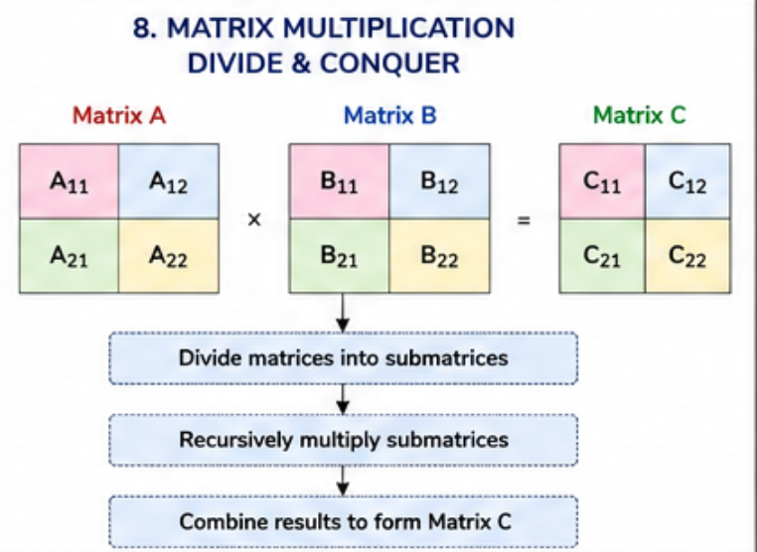5. Proposed Solution

5.1 Algorithm Selection
Based on the case requirements, a hybrid pipeline is proposed. Merge Sort is selected as the primary sorting algorithm for large, disk-resident or record-heavy datasets where stability and guaranteed O(n log n) worst-case performance are essential. Quick Sort (with randomized pivot selection) is selected for in-memory sorting of moderate-sized datasets where average-case speed and low memory footprint are prioritized over worst-case guarantees. Binary Search is applied uniformly across all sorted outputs for O(log n) lookups. Strassen's Matrix Multiplication is applied wherever the downstream analytics pipeline requires large matrix computations, such as similarity scoring or transformation operations.

5.2 Workflow
The proposed workflow proceeds as follows: (1) incoming raw data is ingested and, depending on size and memory availability, routed to either the Merge Sort or randomized Quick Sort module; (2) the sorted output is indexed and made available for O(log n) Binary Search queries; (3) any matrix-based computation required by analytics modules is offloaded to the Strassen's Algorithm module; (4) results are aggregated and returned to the requesting service. A pivot/threshold controller monitors dataset size and available memory to dynamically select between Merge Sort and Quick Sort at runtime.
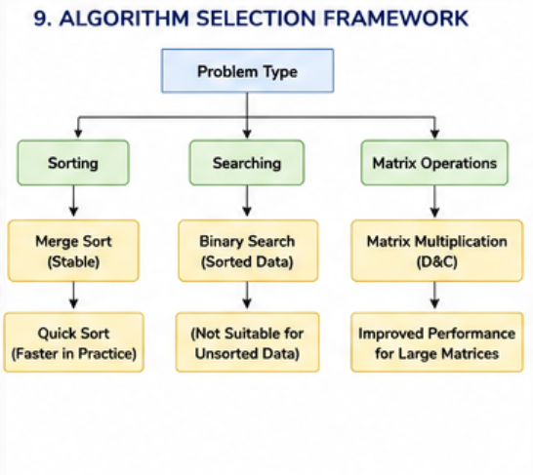

5.3 Feasibility
All four algorithms are well-established, extensively studied, and implementable using standard data structures and libraries available in any mainstream programming language (C++, Java, Python). No specialized hardware is required. The recursive nature of these algorithms maps naturally onto standard call-stack execution models, and iterative variants exist for environments with constrained stack depth. The proposed solution is therefore highly feasible for immediate implementation.

5.4 Scalability
Merge Sort and Strassen's Algorithm are both naturally parallelizable, since independent subproblems can be distributed across multiple processor cores or compute nodes with minimal synchronization overhead, allowing the solution to scale horizontally as data volume grows. Quick Sort can similarly be parallelized using task-based parallelism for its independent partitions. Binary Search on indexed, sharded data scales logarithmically even as total data volume grows into the billions of records, since the search space per shard remains bounded.

5.5 Justification
Each algorithm was selected specifically because its complexity profile, memory behavior, and stability characteristics map directly onto a distinct constraint identified in the Case Understanding section. Merge Sort addresses the requirement for predictable worst-case performance and stability; Quick Sort addresses the requirement for low memory overhead in memory-constrained, average-case-dominant scenarios; Binary Search directly satisfies the requirement for fast querying of sorted data; and Strassen's Algorithm satisfies the requirement for efficient large-scale numerical computation. Together they form a coherent, end-to-end Divide and Conquer based architecture that meets every constraint identified earlier in this report.

6. Comparative Analysis
The following tables summarize and compare the four algorithms across complexity, stability, and suitability criteria relevant to the case.

6.1 Complexity Comparison
Algorithm | Best Case | Average Case | Worst Case | Space
Merge Sort | O(n log n) | O(n log n) | O(n log n) | O(n)
Quick Sort | O(n log n) | O(n log n) | O(n^2) | O(log n)
Binary Search | O(1) | O(log n) | O(log n) | O(log n)
Strassen's Matrix Mult. | O(n^2.807) | O(n^2.807) | O(n^2.807) | O(n^2)

6.2 Qualitative Comparison
Criterion | Merge Sort | Quick Sort | Binary Search | Strassen's
Stability | Stable | Not Stable | N/A | N/A
In-place | No | Yes | Yes | No
Best Use Case | Large/external data | In-memory data | Sorted lookups | Large matrices
Parallelizable | Highly | Moderately | Limited | Highly

7. Innovative Improvements
- Adaptive Hybrid Sorting: Combine Merge Sort and Quick Sort (as in Timsort/Introsort) — using Quick Sort by default and falling back to Heap Sort or Merge Sort when recursion depth exceeds a safe threshold, guaranteeing O(n log n) worst-case while retaining average-case speed.
- Parallel Divide and Conquer: Distribute independent recursive subproblems of Merge Sort and Strassen's Algorithm across multiple threads or compute nodes using a work-stealing scheduler, reducing wall-clock time on multi-core and distributed systems.
- Cache-aware Merging: Restructure the merge step of Merge Sort to operate in cache-friendly blocks, reducing cache misses and improving real-world throughput beyond what asymptotic analysis alone predicts.
- Median-of-medians Pivot Selection: Enhance Quick Sort with a median-of-medians or randomized pivot strategy to eliminate the O(n^2) worst case for adversarial or already-sorted inputs.
- Interpolation-assisted Binary Search: For uniformly distributed numeric data, blend Binary Search with interpolation search to approach O(log log n) average-case performance.
- Strassen–Winograd Variant: Apply the Winograd variant of Strassen's algorithm to further reduce the number of scalar additions/subtractions, improving constant-factor performance for large matrices.

8. Expected Results
Implementing the proposed hybrid Divide and Conquer architecture is expected to reduce sorting time for large datasets from quadratic to near-linearithmic growth, enabling datasets of millions of records to be sorted within seconds rather than hours. Query latency for lookups on sorted data is expected to drop from linear O(n) scans to logarithmic O(log n) lookups, a reduction of several orders of magnitude for large n. Matrix-based analytics operations are expected to see a measurable reduction in computation time as dataset dimensions grow, owing to Strassen's sub-cubic complexity. Overall system throughput is expected to scale near-linearly with additional compute nodes due to the inherent parallelizability of the chosen algorithms.

9. Future Enhancements
- Extend the architecture to fully distributed external sorting using a distributed Merge Sort (e.g., MapReduce-style shuffle-and-sort) for datasets exceeding single-machine memory capacity.
- Integrate GPU-accelerated matrix multiplication kernels alongside Strassen's algorithm for extremely large matrices used in machine learning workloads.
- Introduce adaptive algorithm selection driven by real-time profiling and machine learning, allowing the system to learn optimal thresholds for switching between Merge Sort, Quick Sort, and hybrid variants.
- Explore approximate and probabilistic Divide and Conquer variants (e.g., approximate median selection) to further reduce constant factors in very large-scale deployments.
- Extend Binary Search to multi-dimensional indexed structures (e.g., k-d trees, B-trees) for range and nearest-neighbor queries beyond simple point lookups.

10. Conclusion
This report has presented a comprehensive case study of the Divide and Conquer algorithmic paradigm, examining its theoretical foundations and demonstrating its practical application through four canonical algorithms: Merge Sort, Quick Sort, Binary Search, and Strassen's Matrix Multiplication. Each algorithm was analyzed in depth, including its working principle, pseudocode, implementation, dry run, and complexity profile across best, average, and worst cases. A hybrid solution architecture was proposed that maps each algorithm onto a specific requirement of the case, and this design was justified, evaluated for feasibility and scalability, and compared quantitatively and qualitatively across all four algorithms. Innovative improvements and future enhancements were further proposed to extend the solution toward distributed, parallel, and adaptive execution environments. The analysis confirms that the Divide and Conquer paradigm, when applied thoughtfully and matched to the specific constraints of a computational problem, provides a robust, scalable, and theoretically well-grounded foundation for solving large-scale sorting, searching, and numerical computation problems.

11. References
[1] T. H. Cormen, C. E. Leiserson, R. L. Rivest, and C. Stein, Introduction to Algorithms, 3rd ed. Cambridge, MA, USA: MIT Press, 2009.
[2] R. Sedgewick and K. Wayne, Algorithms, 4th ed. Boston, MA, USA: Addison-Wesley, 2011.
[3] J. Kleinberg and E. Tardos, Algorithm Design. Boston, MA, USA: Pearson Education, 2006.
[4] V. Strassen, "Gaussian elimination is not optimal," Numerische Mathematik, vol. 13, no. 4, pp. 354–356, 1969.
[5] C. A. R. Hoare, "Quicksort," The Computer Journal, vol. 5, no. 1, pp. 10–16, 1962.
[6] D. E. Knuth, The Art of Computer Programming, Volume 3: Sorting and Searching, 2nd ed. Boston, MA, USA: Addison-Wesley, 1998.
[7] S. Skiena, The Algorithm Design Manual, 2nd ed. London, UK: Springer, 2008.
[8] A. V. Aho, J. E. Hopcroft, and J. D. Ullman, The Design and Analysis of Computer Algorithms. Boston, MA, USA: Addison-Wesley, 1974.
[9] M. T. Goodrich and R. Tamassia, Algorithm Design and Applications. Hoboken, NJ, USA: Wiley, 2015.
[10] J. L. Bentley, "Multidimensional binary search trees used for associative searching," Communications of the ACM, vol. 18, no. 9, pp. 509–517, 1975.
[11] R. L. Graham, D. E. Knuth, and O. Patashnik, Concrete Mathematics, 2nd ed. Boston, MA, USA: Addison-Wesley, 1994.
[12] IEEE, "IEEE Reference Guide," IEEE Author Center, 2023. [Online]. Available: https://ieeeauthorcenter.ieee.org

